Activity: Make a Bug House
We have provided some straws and some twine for you to help each other to make a bug house!
Get handful of straws and help each other to tie them together to create a bundle as shown in the illustration below.
Tie another ‘handle’ onto the bundle – this can be used to hang your bug house.

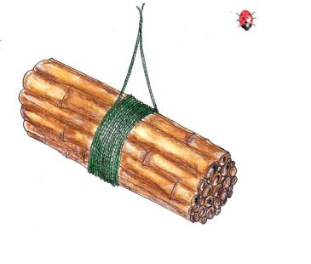
When you get home hang your bug home in the garden or give it to a friend or neighbour with a garden.

Hanging tips
Keep the rain out! If rain gets in the bug house, your insects could drown. Tilt the front slightly downwards when hanging it, so water can drain out.
Secure it carefully so that your bug home can’t be blown away in the wind so somewhere sheltered where it is warm but not too hot.

